**Missouri Jobs and Interns Website**

**Introduction:**

This website is basically designed for Missouri state companies who can provide jobs and interns for the students, and people who are searching for the jobs. Through this website users can search find jobs and apply for the required jobs by registering into the system and also estimate the salary for their experience. The admin can login to the website and look for the applicants who applied for the jobs and also the inactive users onto the system.

**Functional Flow:**

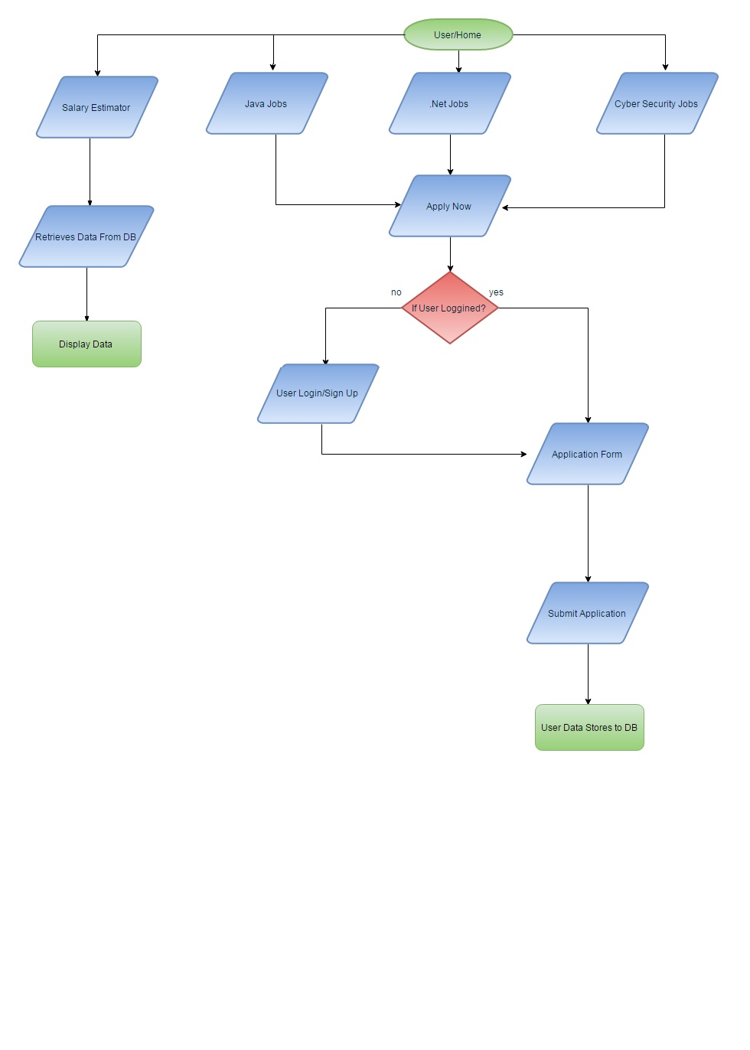Fig 1. Functional Flow Diagram

1. Home Page: Here the user can surf through the available jobs such as Java or .Net or Security jobs. Now if the user is already logged in it will redirect to application form else it will ask user to login to the system and proceed further.
2. Registration page: After a registered user clicks apply now button it will redirect the user to fill the application form. Here every mandatory field needs to be filled to apply for the job and resume of .DOCX need to be uploaded, It will save the uploaded resume to the resume folder of project root folder and details are stored in the table.
3. Salary Estimator Page: We can estimate the salary of an IT Employee based on the years of experience they have.
4. Admin Login: Admin can login to the system and see the selected Java, .Net and cyber security profiles based on the join query of the selected criterion. He can also check the user inactive days and delete the inactive user if he wants to

**Sample User Logins:**

---------------------------------------------------------------------------------------------------------------------------------------------------

Username: nandini          Username: jack         Username: john

Password: 123456           Password: 123456     Password: 123456

---------------------------------------------------------------------------------------------------------------------------------------------------

**Admin User Logins:**

-------------------------------------------------------------------------------------------------------------------------------------------------- **Admin Username**: admin

**Admin Password**: admin

---------------------------------------------------------------------------------------------------------------------------------------------------

**How to Run the Project:**

Step1: Open Visual Studio 2012

Step2: Open the project folder

Step3: Select the Home.aspx Page and run with Google chrome

Step4: click on user login to login and continue to apply now. And follow the on screen instructions.